X5 Pager Service and Repair
102-xxxx
27th July 2010

© Copyright Infostream Pty Ltd
No part of this document may be reproduced in any form, stored in a retrieval system or transmitted without the prior written permission of Infostream.
This document is classified Commercial in Confidence. It is subject to a confidentiality agreement between Infostream and its customers and partners. Its contents must not be divulged to third parties.
Table of Contents
1 Introduction............................................................................ 3
2 Disassembling the Pager........................................................ 4
3 Receiver Board Modification................................................ 14
4 Receiver Board Test............................................................... 14
5 Re-assembly of Pagers.......................................................... 14
6 Testing of Pagers.................................................................... 19

1 Introduction
1.1 Scope
This document describes the process to service and repair an X5 pager. It documents the steps to disassemble the pager, the modifications / repair work identified and the re-assembly and testing of the pager.
It concentrates on service level 3 (as described below); service levels 1 and 2 are summarised and may be addressed more completely by other documents.
1.2 The X5 Service Process
1.2.1 General
Infostream is committed to supporting X5 customers through a network of repair and service agencies. The overall X5 service process facilitates an integrated, end-to-end service and repair path for damaged or faulty X5 units.
It is critical that persons at all points along the service path understand the overall process as a part of Infostream’s commitment to delivering customer satisfaction.
1.2.2 Service Levels
There are three basic level of servicing:
• Service Level 1—initial, customer-level, collation and inspection of units reported as faulty; and
• Service Level 2—basic, service provider level, verification of reported symptoms and functional testing; and
• Service Level 3—workshop analysis and repair of units.
1.2.3 Service Level 1
The activities that are expected to occur at service level 1 include, but are not limited to;
• Reception of end-user fault reports;
• Visual inspection of units for cosmetic/structural damage;
• Discussion with the end-user regarding usage, and facilitating instruction/training if required;
• Inspection/replacement of accessories (e.g. holster, lanyard);
• Inspection/replacement of battery;
• Provision of a temporary or permanent replacement unit where appropriate;
• Completion of fault report and referral to service level 2 as required.
1.2.4 Service Level 2
The activities that are expected to occur at service level 2 include, but are not limited to;
• Reception of fault reports and units from service level 1;
• Analysis and confirmation (or otherwise) of the reported fault;
• Checking the pager message reception;
• Updating the pager firmware if required;
• Conducting built-in diagnostics, and recording results;
• Determination of the feasibility of repair, and referral of the unit and fault report to service level 3 if appropriate.
1.2.5 Service Level 3
At service level 3 you will be required to do the following:
a) Receive the X5 pager and fault report from service level 2;
b) Confirm (or otherwise) the report e.g. by visual inspection or using the X5’s built-in diagnostic functions;
c) If appropriate, undertake basic unit disassembly in accordance with the procedures outlined in Section xx;
d) Test the various subassemblies in accordance with the technical specifications and circuit descriptions in Section xx;
e) Repair / replace subassemblies as appropriate,
f) Re-assemble the pager and conduct appropriate functional tests, in accordance with Section xx;
g) Complete the ‘Resolution’ section of the fault report appropriately and return the completed report and unit to service level 2.

2 Necessary Tools and Environment
2.1 General
Read the following notes carefully before disassembling the pager or carrying out any of the repair procedures detailed in this document.
2.2 Environment
2.2.1 Dust-free and Anti-static
The facility where the pager is disassembled and re-assembled must be dust-free. Anti-static mats must be used when the pager is being assembled.
2.3 Tools Required
There are tools required for the disassembly and assembly of the pagers.
2.3.1 Screwdriver
A Torx screwdriver with a head dimension of T-6.
2.3.2 Disassembly Tool
There is no standard off-the-shelf X5 disassembly tool available. However, a number of commercially available tools may be adapted for the purpose by a competent machinist.
The general requirements for the tool are:
• Comfortable handle / grip;
• Blade to be between xx and xx mm wide, to avoid excessive damage to the casing;
• Blade to be thin enough to enter the casing separation, but not razor sharp due to the danger to personnel;
• Blade to be strong, but not brittle (for example, razor bladed tools are not suitable as the blades cannot resist the twisting forces required).

3 Disassembling the Pager
3.1 Procedure
Care needs to be taken when disassembling the X5 pager. All parts of the same pager must be kept together after the pager has been disassembled. This is especially important with the back casing (with the ESN on the label) and the digital board (with the ESN already programmed).

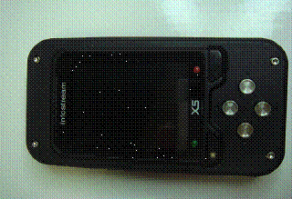
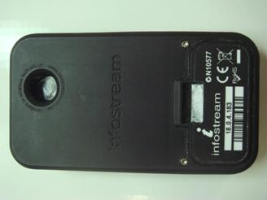

The following steps must be followed:
3.1.1 Step 1 – Undo the screws
The X5 pager has six screws on the front and back of the pager (4 screws in front and 2 screws at the back).
Using a screwdriver, undo all six screws.
3.1.2 Step 2 – remove the back cover
Apart from the screws, the pager is held together by internal hooks located on the front and back covers. After the screws have been removed, therefore, it will require some slight force to pull the pager apart.

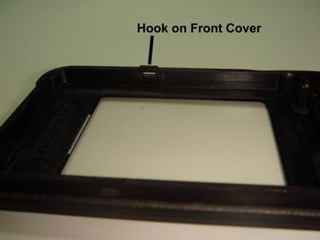

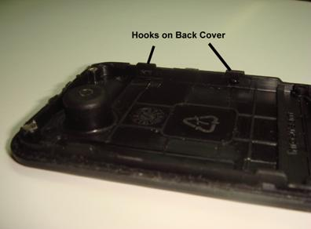

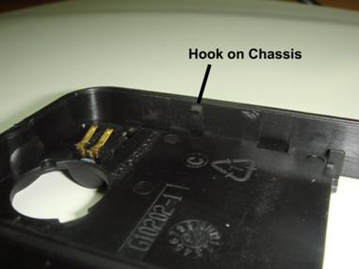

Starting at the top corners, carefully but firmly prise the back cover off. Be careful not to distort the cover or scratch the pager. Be sure that no components are dislodged, (caution: the coil in the coil cradle of the digital board could be dislodged if the back case is prised off incorrectly).

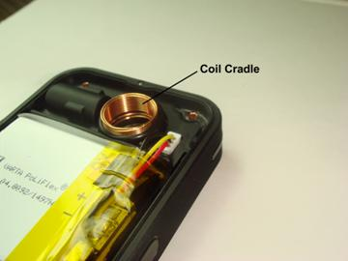

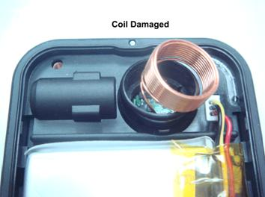
3.1.3 Step 3 – remove the front cover
Similarly, separating the front cover from the chassis will require some slight force. Start at the top end. Take care not to touch the boards and electronics when removing the front cover.
You should then be left with a front cover, a back cover and a partial assembly made up of the chassis with all the boards intact.

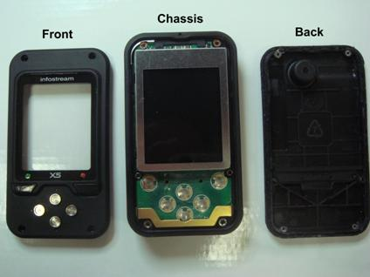
3.1.4 Step 4 – Unplug the battery
The battery cable is very short and can easily be damaged if the battery is unplugged incorrectly. Do not remove the plug from the socket by grabbing the cables. This will cause the cables to detach from the plug.
The battery plug has a lip around it, most prominent along two sides: at the top of the pager and on the side nearest the coil cradle. Using a small flat-head screwdriver, lever the lip around the white battery plug along the two sides with the most prominent lip. The plug will be detached from the battery cable socket.

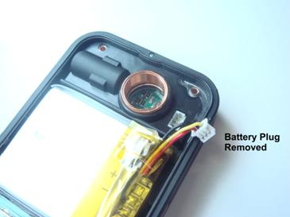

3.1.5 Step 5 – Separate the boot assembly from the chassis
The partial assembly consists of the chassis with both the receive board and the digital board still connected and held together with the boot around the electronic boards.
Unlock the partial assembly by carefully pushing the coil thus causing the digital board & boot to be released from the top end of the chassis.

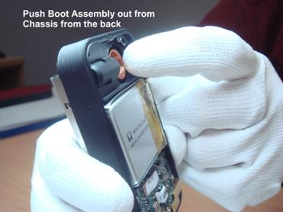

The boot surrounding the electronic boards could sometimes catch on the chassis. If so, gently prise the boot from the chassis so that the boot and boards remain together.
Caution: take care not to touch the IrDA on the digital board at any time as it is easily damaged.
Slide the boot assembly out from the chassis.
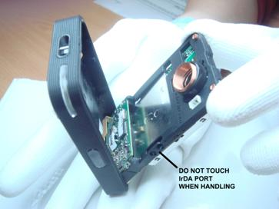

The PCBs are still connected and intact in the boot.

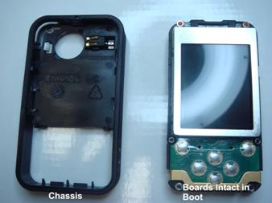

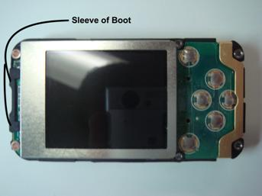

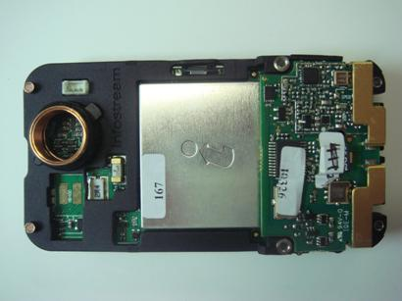

3.1.6 Step 6 – Remove the digital board from boot
Note that at the top end of the boot assembly, the sleeve is extra wide, helping to hold the digital board within the boot. Detach the boot from the digital board at the top end first by peeling the sleeves of the boot away from the board.
Be careful not to drag the coil or coil cradle with the boot. Again, take care not to touch the IrDA on the digital board at any time as it is easily damaged.
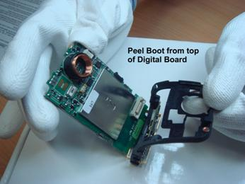

There is a connector holding the digital board and receiver board together. The connector will not be visible when the two boards are together. Separate the two PCBs by disconnecting the digital board from the receiver board then sliding the digital board out from the boot.

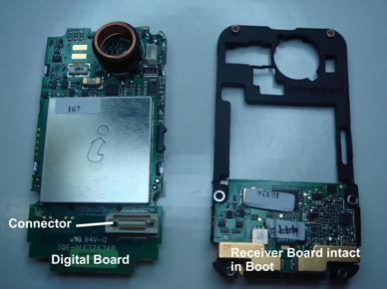
3.1.7 Step 7 – Remove the receiver board from boot
Remove the receiver board from the boot at the antenna end. It will be necessary to squeeze the boot at the antenna end to do so.

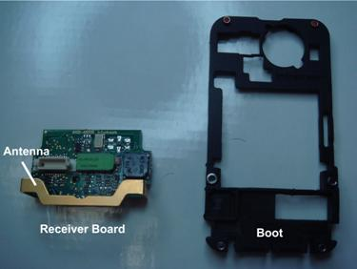

3.1.8 Step 8 – Parts in Trays
Finally, ensure that each and every part of the pager that has been disassembled is laid out systematically on a tray.

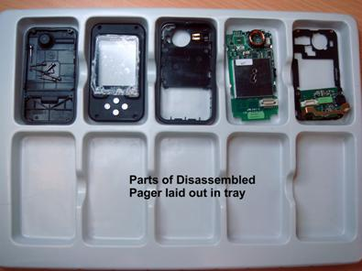

4 Receiver Board Modification
The receiver boards need to be modified. See doc 102-5124 for the modification instructions.

5 Receiver Board Test
Following modification, the receiver boards need to be tested. Refer to doc 102-1119 (X5 Receiver Board Test Fixture User Guide) for a full suite of the tests.
Receiver board test jigs (fixtures) will be made available.

6 Re-assembly of Pagers
The pagers will then need to be re-assembled following these assembly instructions:

Instruction | Quality control | Notes
Install the receiver PCB into the boot assembly | Confirm that the boot is assembled correctly, the speaker hole is aligned to the boot opening, the boot is correctly seated on the PCB and fitted around the antenna. | 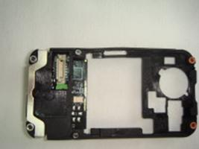  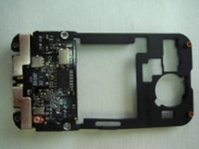
Install the digital PCB into the boot and receiver assembly. Connect the digital PCB to the receiver PCB. | Confirm that the digital PCB is connected to the receiver PCB (there should be a smart “click” when the PCBs are connected). | 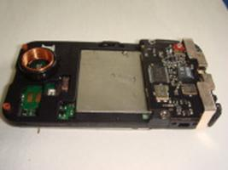
Lightly stretch the boot on all four sides to ensure it holds the PCBs firmly in place. | Confirm the PCBs are secured in the boot assembly. | 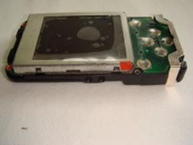
Assemble the vibrator in the chassis | Confirm that the connector points of the vibrator are facing up. | 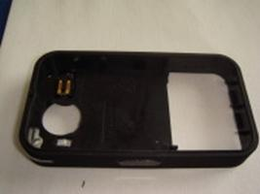
Slide the assembly into the chassis at the antenna end. Lightly press around the sides of the chassis. Ensure the boot is not caught by the chassis and detached from the PCBs. | Confirm that the assembly is secured into the chassis correctly. | 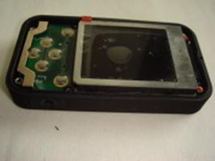
Remove the backing tape from the double-sided tape on the chassis and secure the battery. | Confirm that the battery is correctly secured. | 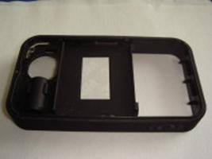
Connect the battery to the digital PCB by plugging the battery into the socket on the digital PCB. | Press the digital board into the chassis to ensure good contact with the vibrator.  Confirm that the pager powers up by observing the screen turning on. | 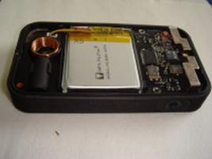
Receiver 455kHz alignment. |  | Skip this step for the synthesized units
Assemble the rear cover to the chassis assembly, firmly clicking in all sides. |  | 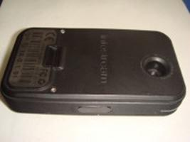
Remove the protective film from the LCD.
Clean the LCD of any dust particles using compressed air and an ioniser.
Remove protective film from the inside of the front cover lens | Ensure there is no dirt or glue residue on the lens. Clean with soft cloth if needed.
Clean the lens from any dust particles using compressed air and an ioniser.
Secure the front cover to the chassis assembly. Firmly press the front cover to lock into chassis | Check and confirm that the lens & LCD are free from any particles and/or obstructions. | 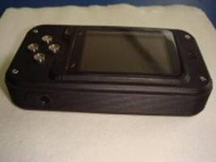
Install the 2 rear screws.
Install the 4 front screws. | Check to make sure the screws have been installed correctly and firmly secured.
Conduct hardware diagnostic test. See section on Testing the Pager. | Issue "IPQC inspection results (hardware test) - cased" report
Conduct antennae alignment and sensitivity test on pager. See section on Testing the Pager. | Issue "IPQC inspection results (receiver) - cased" report
Conduct antennae alignment over the full frequency range. See section on Testing the Pager. |  | Skip this step for crystal based units.
Fully charge the pager | Confirm the pager is charged to 100%

7 Testing of Pagers
The pagers will be tested according to the following procedure:
- Ensure that the correct version of the test firmware has been uploaded.
- Complete the following tests as described in the test documentation:
- Hardware diagnostic tests
- Antenna alignment and sensitivity tests
- Antenna alignment over the full frequency range.
Refer doc 102-1120 (X5 Digital Board Test Firmware User Guide).
- Update the tuning map and check that the ESN and production firmware versions are correct.

